First Aid Assignment

- Choose an injury or emergency situation.
- List the signs and symptoms.
- List the recommended treatment and care.
- You can make a poster (11x17 paper), mini power point, Pic-collage, chart or other format approved by Gaudet.
- You can use your guidebook or internet sources.

Tick bite Concussion Bee sting
Glass in foot Sun burn Burn from cooking
Food poisoning Seizure Broken arm or leg
Asthma attack Choking Something in eye
Dehydration Nosebleed Heat stroke
Sprained ankle Allergic reaction Diabetic emergency
CPR Head and facial injuries Spinal injury
Chemical burns Severe bleed

Casualty management
Scene survey
Shock management
First Aid kit
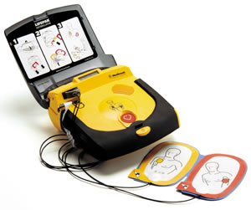
Using an AED

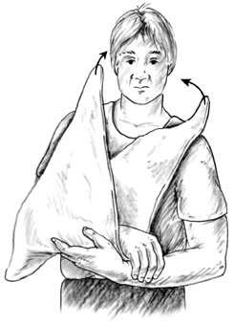

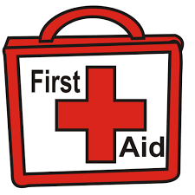

CRITERIA | 3 POINTS | 2 POINTS | 1 POINT | TOTALS
Signs and symptoms of the injury or emergency are listed or demonstrated | All signs and symptoms are clearly listed or demonstrated | Most signs and symptoms are listed or demonstrated | Few signs and symptoms are listed or demonstrated
Reader would be able to follow your steps, diagrams or description to be able to treat this emergency situation. | Steps to treat the injury/situation are clearly outlined and would be easy to follow in an emergency situation. | Steps to treat the injury/ situation are somewhat outlined and would be somewhat able to follow in an emergency situation. | Steps are unclear and would be difficult to follow in an emergency situation.
Follow up care is detailed and described. | Steps to follow up the care and treatment are clearly outlined and would be easy to follow in an emergency situation. | Steps to follow up the care and treatment are outlined and would be somewhat difficult to follow in an emergency situation. | Steps to follow up care and treatment are poorly outlined and difficult to follow in an emergency situation.

